React

Create a React Application named “cricketapp”

1. ListofPlayers

* Declare an array with 11 players and store details of their names and scores using the map feature of ES6
* Filter the players with scores below 70 using arrow functions of ES6.

import React from 'react';

const ListofPlayers = () => {

  const players = [

    { name: 'Virat', score: 85 },

    { name: 'Rohit', score: 95 },

    { name: 'Dhoni', score: 65 },

    { name: 'Rahul', score: 55 },

    { name: 'Pant', score: 75 },

    { name: 'Jadeja', score: 45 },

    { name: 'Bumrah', score: 80 },

    { name: 'Shami', score: 60 },

    { name: 'Ashwin', score: 50 },

    { name: 'Gill', score: 90 },

    { name: 'Iyer', score: 40 },

  ];

  const lowScorers = players.filter(player => player.score < 70);

  return (

    <div>

      <h2>All Players</h2>

      <ul>

        {players.map((p, index) => (

          <li key={index}>{p.name} - {p.score}</li>

        ))}

      </ul>

      <h2>Players with Score below 70</h2>

      <ul>

        {lowScorers.map((p, index) => (

          <li key={index}>{p.name} - {p.score}</li>

        ))}

      </ul>

    </div>

  );

};

export default ListofPlayers;

1. IndianPlayers
   1. Display the Odd Team Player and Even Team players using the Destructuring features of ES6
   2. Declare two arrays T20players and RanjiTrophy players and merge the two arrays and display them using the Merge feature of ES6

import React from 'react';

const IndianPlayers = () => {

  const teamPlayers = ['Player1', 'Player2', 'Player3', 'Player4', 'Player5', 'Player6'];

  const oddTeam = teamPlayers.filter((_, index) => index % 2 !== 0);

  const evenTeam = teamPlayers.filter((_, index) => index % 2 === 0);

  const T20Players = ['Rohit', 'Virat', 'Bumrah'];

  const RanjiPlayers = ['Pujara', 'Rahane', 'Ishant'];

  const allPlayers = [...T20Players, ...RanjiPlayers];

  return (

    <div>

      <h2>Odd Team Players</h2>

      <ul>{oddTeam.map((p, i) => <li key={i}>{p}</li>)}</ul>

      <h2>Even Team Players</h2>

      <ul>{evenTeam.map((p, i) => <li key={i}>{p}</li>)}</ul>

      <h2>List of Indian Players Merged</h2>

      <ul>{allPlayers.map((p, i) => <li key={i}>{p}</li>)}</ul>

    </div>

  );

};

export default IndianPlayers;

import ListofPlayers from './components/ListofPlayers';

import IndianPlayers from './components/IndianPlayers';

function App() {

  const flag = false;

  return (

    <div className="App">

      <h1>🏏 Welcome to Cricket App</h1>

      {flag ? <ListofPlayers /> : <IndianPlayers />}

    </div>

  );

}

export default App;

Display these two components in the same home page using a simple if else in the flag variable.

**Output:** When Flag=true

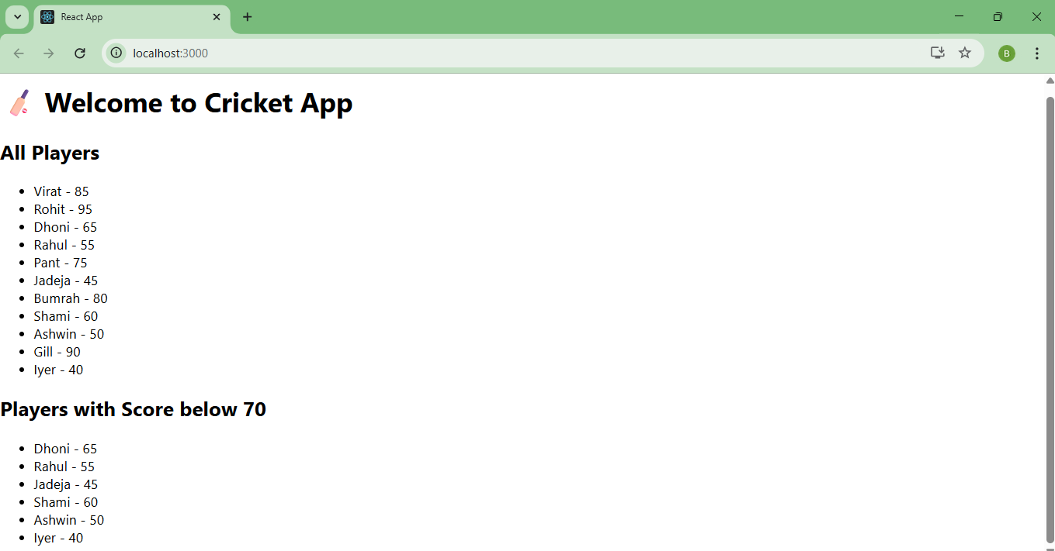

When Flag=false

